LADI-v2 Multi-label Disaster Imagery Project
Backbone Classifier + Static Label Graph + GCN + Dynamic GCN
Kaggle P100-ready pipeline report and implementation guide

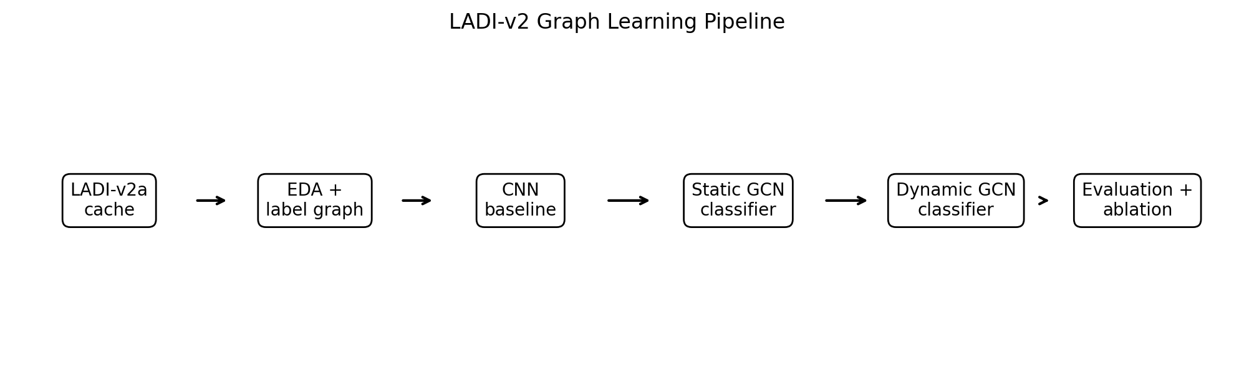

1. Executive Summary
This report documents a complete runnable pipeline for LADI-v2 multi-label classification. The pipeline starts with a conventional CNN backbone, builds a train-only static label graph from LADI-v2 label co-occurrence, uses Graph Convolutional Networks (GCNs) to inject label dependency structure, and then extends the method with an image-conditioned Dynamic GCN. The Dynamic GCN is the main methodological contribution because it lets label relationships change per image rather than treating all disaster scenes as having the same fixed label dependency pattern.
The delivered project includes six notebooks, reusable PyTorch source modules, Kaggle running instructions, and this report. The implementation is designed for the Tesla P100 GPU: ResNet18 is the safe development default, EfficientNet-B0 is the stronger practical option, mixed precision is enabled, and batch sizes are set conservatively.

2. Dataset and Problem Setting
LADI-v2 is a low-altitude aerial disaster imagery dataset released by MIT Lincoln Laboratory. The dataset card describes the images as Civil Air Patrol disaster images labelled by trained CAP volunteers for multi-label classification, with majority vote used when volunteers disagree. The project uses the v2a label set because it is practically useful, compact, and recommended by the dataset card for most use cases.
Item | Project choice
Dataset | MITLL/LADI-v2-dataset from Hugging Face
Configuration | v2a_resized / default v2a-style label set
Task type | Multi-label image classification
Labels | 12 binary labels: infrastructure, flood, debris, road/tree/water/building signals
Primary metric | Macro average precision, with macro/micro F1 also reported
Reason for macro AP | Better suited to imbalanced multi-label disaster classes than plain accuracy

The official dataset card states that the train and validation data are drawn from federally declared disaster imagery from 2015-2022, while the test split is drawn from 2023 events. This creates a realistic distribution-shift evaluation setting: a model must generalise to future disaster events rather than only memorising past event conditions.

3. Relationship to the Uploaded Codebase
The uploaded ZIP contained two relevant research prototypes: a label-graph GCN refiner and a graph-attention transformer network originally written for retinal multi-label classification. Those repositories were useful as design references, especially for static label co-occurrence graphs, PMI/conditional probability adjacency matrices, identity/permuted graph controls, and graph-attention ideas. However, the delivered implementation is not a simple rename of the retina code. It is refactored into LADI-specific notebooks and PyTorch modules, with Hugging Face dataset caching, LADI-v2a labels, disaster-image transforms, macro AP evaluation, and a dedicated Dynamic GCN model.

4. Delivered Notebook Pipeline
Notebook | Purpose | Main outputs
00_environment_and_dataset_cache.ipynb | Downloads/streams LADI-v2a and creates Kaggle local cache. | train/val/test CSVs and image folder
01_eda_and_label_graphs.ipynb | Computes label prevalence, density, co-occurrence and static graphs. | A_pmi.pt, A_condprob.pt, plots, graph stats
02_baseline_backbone_training.ipynb | Trains ResNet/EfficientNet multi-label baseline. | Baseline checkpoint, predictions, metrics JSON
03_static_gcn_training.ipynb | Trains static GCN classifier using train-label graph. | Static GCN checkpoint and per-label metrics
04_dynamic_gcn_training.ipynb | Trains image-conditioned Dynamic GCN. | Dynamic GCN checkpoint, predictions, learned gate
05_evaluate_compare_and_inference.ipynb | Aggregates runs and creates comparison tables/plots. | model_comparison_summary.csv and per-label test CSV

5. Methodology

5.1 Stage 1: Backbone Multi-label Classifier
The baseline model extracts image features with a torchvision backbone and predicts all labels with a linear multi-label head. The default is ResNet18 because it is stable on a Kaggle P100; EfficientNet-B0/B2 can be used when more runtime is available. Training uses BCEWithLogitsLoss with class-positive weights derived from training prevalence. Validation macro AP selects the best checkpoint.
Parameter | Default | Why
Backbone | resnet18 | Fast and stable development baseline on P100
Image size | 320 x 320 | Balances aerial-scene detail and GPU memory
Batch size | 16 baseline/static; 8-12 dynamic | Avoids P100 OOM errors
Loss | BCEWithLogitsLoss + pos_weight | Handles multi-label imbalance
Checkpoint selection | Validation macro AP | Robust for imbalanced labels

5.2 Stage 2: Static Graph from Training Label Co-occurrence
The static graph is built only from the training labels to avoid validation/test leakage. The notebook builds PMI, conditional-probability, co-occurrence and identity graphs. PMI is the recommended default because it emphasises positive association above chance, while conditional probability is a useful alternative for directional co-occurrence intuition. The graph is top-k sparsified and symmetrically normalised before GCN propagation.

5.3 Stage 3: Static GCN Classifier
The Static GCN classifier follows the ML-GCN idea: labels have trainable embeddings; graph convolution propagates information across the label graph; the final label representations become classifier weight vectors. The image feature vector is multiplied with these graph-generated label weights to produce logits. This differs from a plain linear head because the label classifier weights are not independent; they are regularised by the disaster-label graph.

5.4 Stage 4: Dynamic GCN Classifier
The Dynamic GCN is the strongest stage. It keeps the static co-occurrence graph as a prior, but also constructs a sample-specific graph from each image feature vector. A learnable gate mixes the static graph and dynamic graph. This matters for LADI-v2 because label dependencies can change across disaster type: for example, flooding, water, roads, buildings, and debris can relate differently in hurricanes, floods, tornado events, and post-event aerial surveys.
Component | Role
Static graph prior | Captures stable train-set label co-occurrence
Image context projection | Injects scene-specific information into label embeddings
Dynamic adjacency | Computes sample-specific label relations using attention-style similarity
Learnable gate | Controls how much the model trusts static vs dynamic structure
Batch GCN | Propagates label representations through the mixed graph for each image

6. Recommended Experiment Plan
Experiment | Graph | Purpose
Baseline CNN | None | Independent-label reference model
Static GCN-PMI | PMI | Main static graph model
Static GCN-CondProb | Conditional probability | Alternative static graph
Static GCN-Identity | Identity | Control for extra parameters without label dependency
Dynamic GCN-PMI | PMI + image-conditioned graph | Main proposed model
Dynamic GCN-CondProb | CondProb + image-conditioned graph | Dynamic alternative

For a fast first pass, run only Baseline CNN, Static GCN-PMI, and Dynamic GCN-PMI. For a dissertation-quality result section, include CondProb and Identity controls. If time allows, repeat the main three models over three seeds and report mean plus standard deviation.

7. Evaluation and Output Files
Each training notebook saves checkpoints, validation/test predictions, a metrics JSON file, and per-label test tables. The final evaluation notebook aggregates runs into a single comparison CSV and creates a macro-AP bar plot. The project does not invent result numbers in this report; final scores should be taken from the Kaggle run outputs.
Metric/output | Why it matters
Macro AP | Primary metric for imbalanced multi-label ranking quality
Macro F1 | Per-label thresholded classification quality
Micro F1 | Overall example-label performance dominated by common labels
Per-label AP/F1 | Shows which disaster labels benefit from graph modelling
Validation-tuned thresholds | Improves F1 without test-set leakage

8. Kaggle P100 Running Guide
Run order:
- Upload/unzip the project folder into Kaggle.
- Enable internet for notebook 00 if downloading directly from Hugging Face.
- Run notebook 00 to create /kaggle/working/ladi_v2a_cache.
- Run notebook 01 to create /kaggle/working/ladi_v2_outputs/graphs.
- Run notebook 02 for the baseline checkpoint.
- Run notebook 03 for static GCN.
- Run notebook 04 for Dynamic GCN.
- Run notebook 05 for final tables and plots.
P100 troubleshooting:
- If CUDA runs out of memory, reduce dynamic batch size from 12 to 8, then reduce image size from 320 to 288.
- If pretrained torchvision weights cannot download, the code falls back to random weights; enabling internet is recommended for stronger results.
- If dataset download is slow, set LIMIT_PER_SPLIT in notebook 00 for a smoke test, then return it to None for the full run.
- Keep outputs under /kaggle/working; download them before the session resets.

9. Risks, Limitations, and Improvements
The Dynamic GCN is more expressive than the static graph model, but it can overfit if the training set is small or if the dynamic gate becomes too dominant too early. The implementation therefore initialises the gate close to the static graph and uses dropout. Future improvements can add explicit graph regularisation, calibration, test-time augmentation, larger backbones, and multi-seed confidence intervals.

10. References
- Scheele, S., Picchione, K., & Liu, J. (2024). LADI v2: Multi-label Dataset and Classifiers for Low-Altitude Disaster Imagery. arXiv:2406.02780.
- MIT Lincoln Laboratory. (2024). MITLL/LADI-v2-dataset. Hugging Face Datasets. DOI: 10.57967/hf/2283.
- Chen, Z.-M., Wei, X.-S., Wang, P., & Guo, Y. (2019). Multi-label image recognition with graph convolutional networks. CVPR.
- Ye, J., He, J., Peng, X., Wu, W., & Qiao, Y. (2020). Attention-driven dynamic graph convolutional network for multi-label image recognition. ECCV.
- Tan, M., & Le, Q. (2019). EfficientNet: Rethinking model scaling for convolutional neural networks. ICML.

